## **🌱 Catalyst Circles – V1 Simplified Feature Overview**

### **✨ What It Is**

A *beautiful, branded space* for spiritual creators to host their podcast, offer self-paced classes, promote coaching/tools, and invite users into upcoming offerings or events.

Think of it as a sacred storefront-meets-sanctuary — built for resonance, not reach.

### **🎯 What It Includes (MVP)**

| **Feature** | **Description** |
| --- | --- |
| **Podcast Player** | Embedded audio episodes with titles, show notes, and optional reflection prompts. |
| **On-Demand Classes** | Pre-recorded classes or video teachings, organized in a clean content library. |
| **Tools & Coaching** | Section for downloadable PDFs, worksheets, or guided tools. Link to book 1:1 sessions or group coaching via Calendly, Practice, or custom link. |
| **Events/Offer Signup** | Promote upcoming retreats, ceremonies, or challenges — with links to register externally. |
| **Catalyst Bio + Sacred Branding** | A custom banner, headshot, intention, and energetic signature (color/symbol/archetype). |
| **Subscription Access** *(V2)* | Option to gate some content under a flat monthly subscription, or leave all free for now. |

### **💫 User Value**

* **Easy access** to the voices, teachings, and tools of spiritual guides they trust
* A **non-fragmented experience** (vs. jumping between Instagram, YouTube, and Linktree)
* A sacred digital space that feels **intentional, calm, and reflective**
* A simple way to **engage deeper** through classes, journaling, or event participation

### **🧑‍💻 Developer Notes**

* **Stack Recommendation:**
  + Webflow + Memberstack OR Next.js + Supabase for dynamic access
  + Use [Resonate](https://resonate.coop/) or Spotify embed for podcast player
  + Upload classes as video modules (host via Vimeo or Mux)
  + Integrate Calendly, Practice, or other booking tools directly via embed
* **Admin Interface:** Simple form-based upload: Title, Description, Media Upload, Link

### **🎨 UX/UI Guidelines**

* Clean card layout with three clear sections:  
   **1. Listen** (Podcast), **2. Learn** (Classes), **3. Engage** (Coaching & Events)
* Use sacred symbolism and subtle motion: e.g., mandalas, elemental shapes, glowing hover states
* Include one **energetic motif or archetype** for each Catalyst — like *The Weaver*, *The Flame*, *The River*

### **🧘🏽 User Flow**

1. **Discover Catalyst** via Mirror Collective’s curated list
2. **Enter Circle** – warm welcome banner, intro message or video
3. **Listen** to the podcast while exploring classes and tools
4. **Sign up** for coaching, live events, or external offerings

## **💸 Catalyst Circles Monetization Model (V1) Fabio**

### **🔁 Revenue Split**

* **70/30 split**
  + **Catalyst:** 70% of revenue they generate
  + **Mirror Collective:** 30% (covers hosting, platform, marketing, margin)

This keeps creators empowered while sustaining the platform.

### **📦 User Access Tiers**

| **Tier** | **Access** | **Price** | **Notes** |
| --- | --- | --- | --- |
| **Free Tier (Platform-Wide)** | Access to select content (tools)across all Catalyst Circles | Included with Mirror Collective base subscription | Encourages discovery |
| **Catalyst-Curated Tiers** | **Creators set pricing for premium content** (classes, bundles, tools) | Catalyst-defined (e.g., $11, $33, $77) | You facilitate checkout & access |

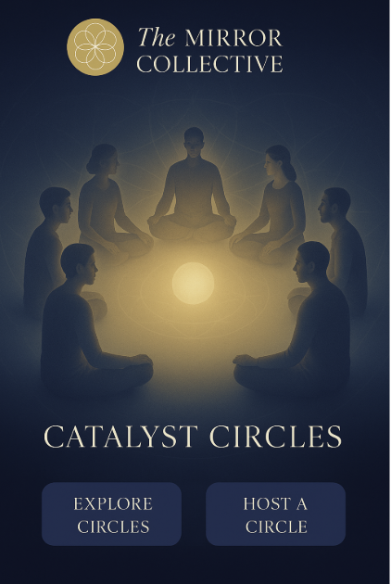

**OR**

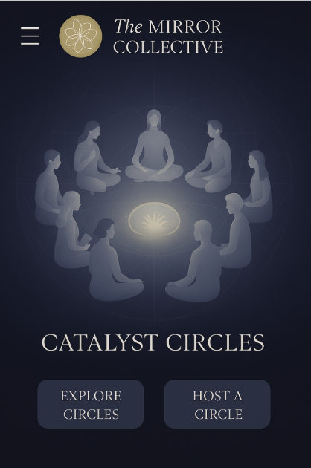

**OR**

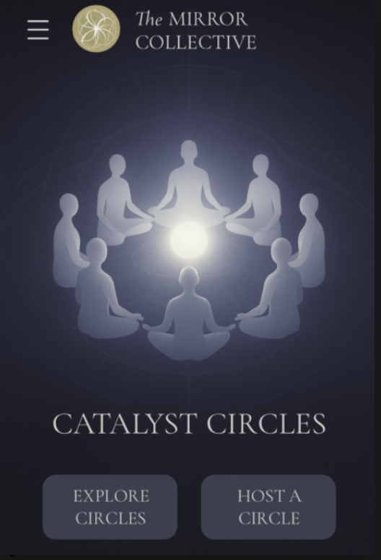

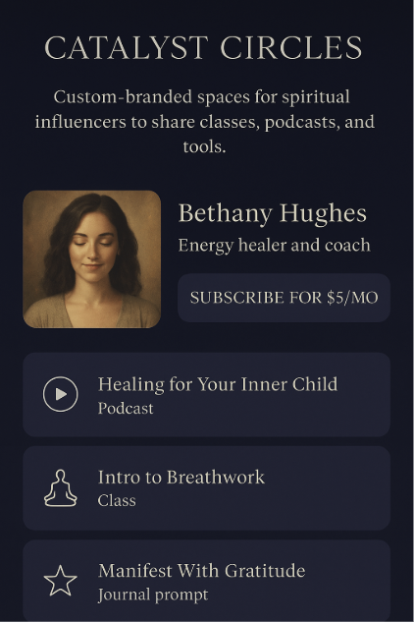

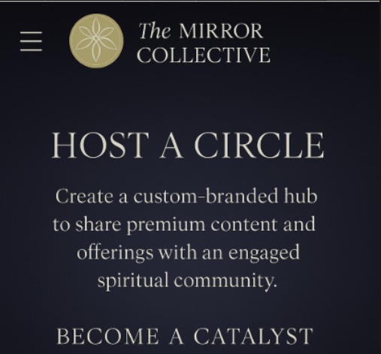

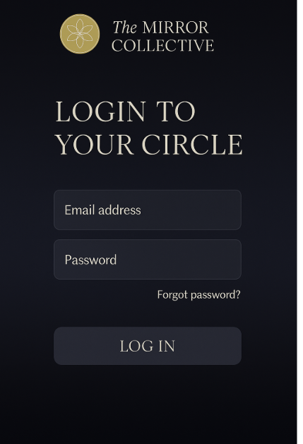

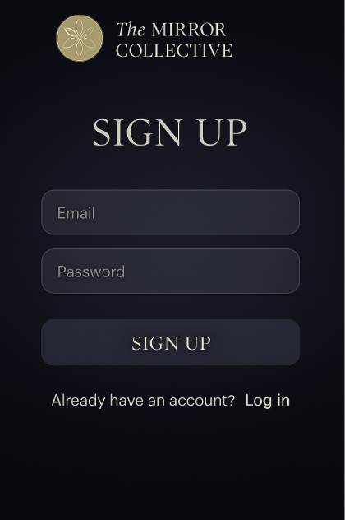

## **✍️ Catalyst Onboarding Flow (Post Sign-Up)**

### **✅ 1. Welcome Message**

Soft onboarding screen with a warm welcome:

*“Welcome, Catalyst. Let’s co-create your sacred space.”*

### **✅ 2. Catalyst Info Form**

A form that gathers:

* **Display Name** (how they want to be seen)
* **Bio / Mission Statement**
* **Photo or Avatar Upload**
* **Content Focus** (e.g. podcast, class, journal prompts)
* **Pricing Preferences** (free/premium, monthly vs bundle)
* **Preferred Payout Email / Stripe or other Setup Link**

### **✅ 3. Digital Agreement (E-Signature) Fabio to develop**

This would be a **simple contract** outlining:

* Your platform’s **terms of use**
* **Revenue share structure** (no need to emphasize the percentage, just say "You retain the majority of all income generated.")
* **Content ownership and rights**
* Platform responsibilities (hosting, access control, light promotion)
* Termination clause

Use a clean e-signature tool embedded in your UI like:

* **HelloSign**
* **Jotform Sign**
* **Typeform + Zapier + PandaDoc**
* **Webflow form + PDF auto-fill + sign flow**

### **✅ 4. Confirmation + Portal Preview**

“Your Circle is opening...”

* Soft preview of their custom space
* Step-by-step guide to upload first content

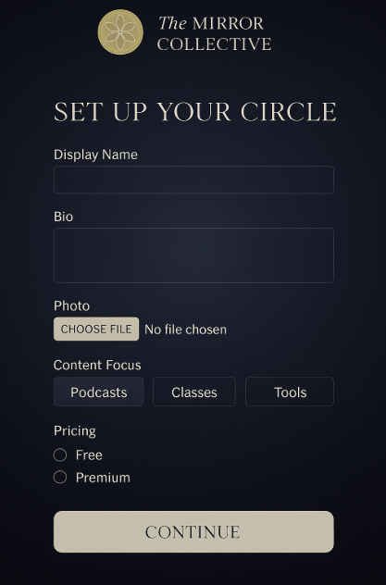

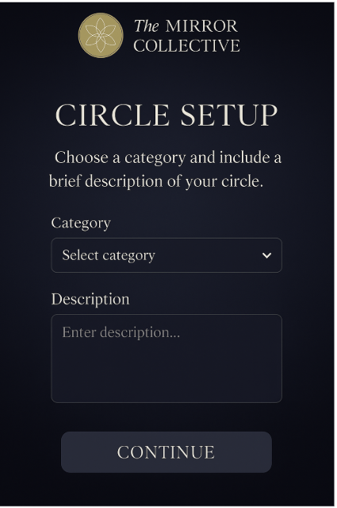

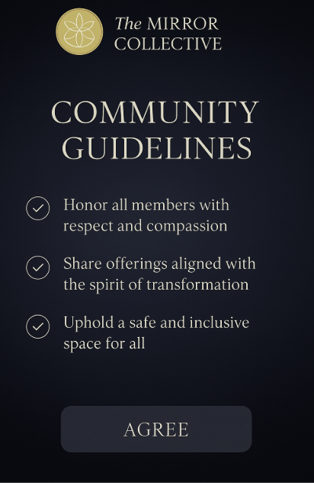

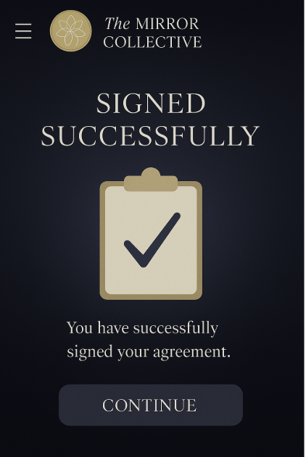

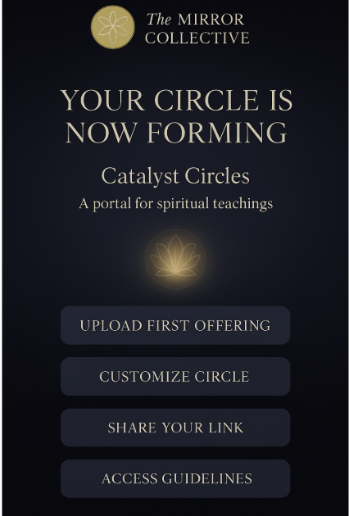

**Need to have set of Guidelines: Fabio**